**Assignment -2**

Data Analytics

|  |  |
| --- | --- |
| Assignment Date | 28 September 2022 |
| Student Name | Mr. A.Inbasekaran |
| Student Roll Number | 19ITA22 |
| Maximum Marks | 2 Marks |

**Dashboard:**

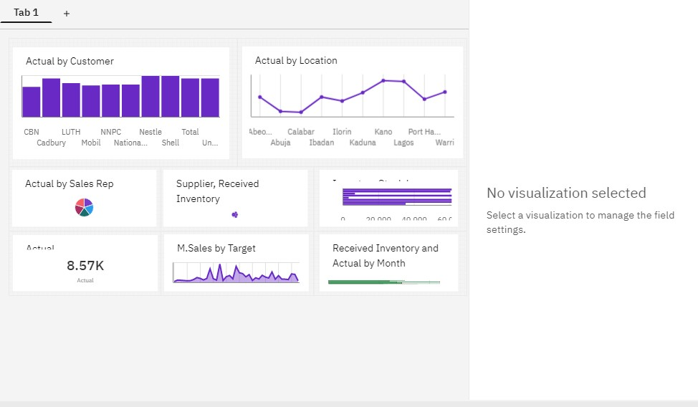

**Link:**

https://us3.ca.analytics.ibm.com/bi/?perspective=dashboard&pathRef=.my_folders%2FAssignment- 2%2FPharma%2BMonthly%2BSales%2BAnalysis%2BCustom%2BDashboard&action=view&mode=das hboard&subView=model00000183846efe12_00000000

**Question-1:**

Sales By Customer.

**Solution:**

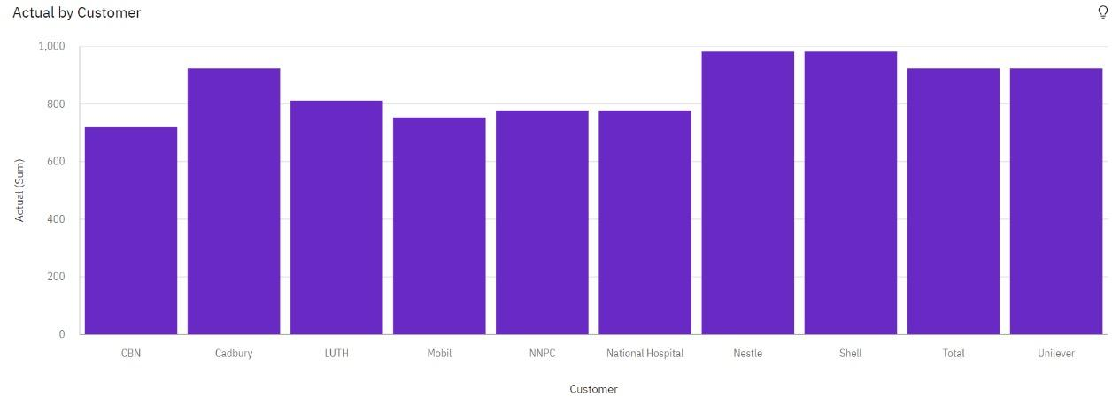

**Question-2:**

Sales By Location.

**Solution:**

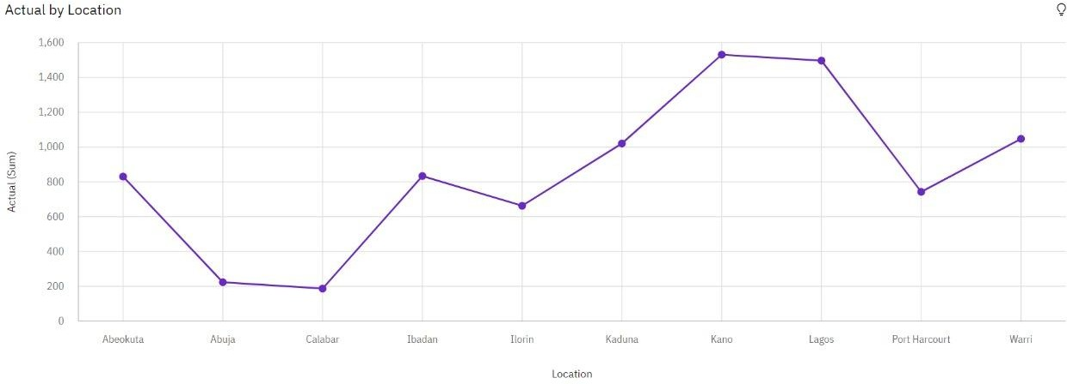

**Question-3:**

Sales By Sales Representative.

**Solution:**

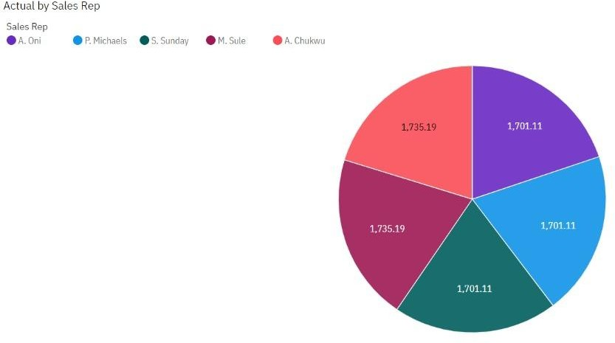

**Question-4:**

Received Inventory From Supplier.

**Solution:**

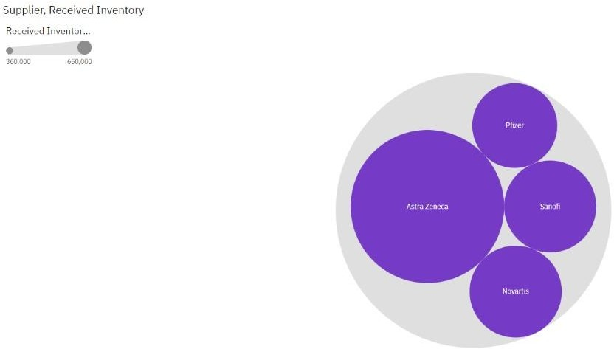

**Question-5:**

Inventory Stock for Warehouse Locations.

**Solution:**

**Question-6:**

Sales Trend.

**Solution:**

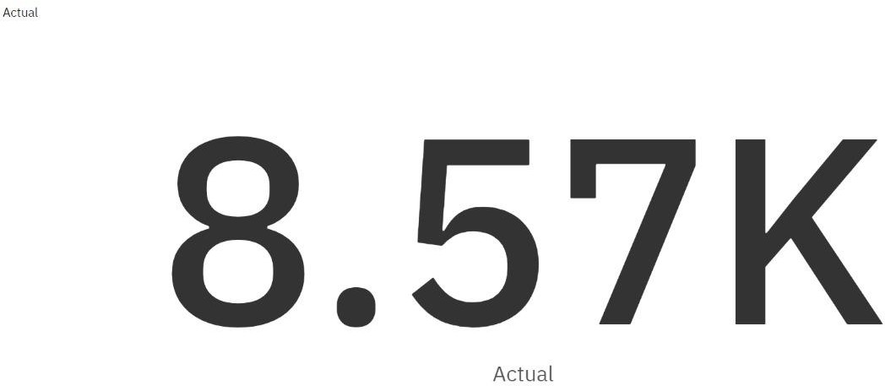

**Question-7:**

Monthly Sales.

**Solution:**

**Question-8:**

Actual and Received Inventory by Month.

**Solution:**

